**Year 9 Light and Sound Revision**

1. Diagrams A and B each represent waves

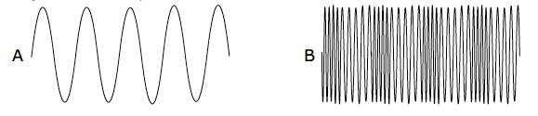

1. What type of wave does diagram A represent?
2. What type of wave does diagram B represent?
3. How many cycles of the wave are shown in diagram A?
4. How many cycles of the wave are shown in diagram B?
5. Which diagram would you use to represent:
6. a wave travelling across the surface of water.
7. a sound wave
8. an electromagnetic wave

2. The diagram below shows a transverse wave.

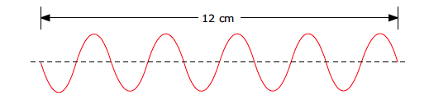

1. Mark the amplitude of the wave with an arrow labeled **A.**
2. Mark the wavelength of the wave with an arrow labeled **B**.
3. How many waves are shown on the diagram?
4. Calculate the wavelength of this wave.

3. The diagram shows four waves, A, B, C and D all drawn to the same scale.

a) Which wave has the lowest frequency?

b) Which wave has the lowest amplitude?

c) Which wave has the longest wavelength?

d) Which wave has the greatest amplitude?

|  |  |
| --- | --- |
| A |  |
| B |  |
| C |  |
| D |  |

4. True or false.

a) Waves can be longitudinal or transverse.

b) Light is an example of a longitudinal wave.

c) The amplitude of a water wave is the distance from crest to crest.

d) Waves are a means of transferring energy without transferring

matter.

5. Complete each of the following :

a) All electromagnetic waves travel at the same s____________ in a vacuum. They are t____________ waves.

Different electromagnetic waves have different f____________, w____________ and e____________.

b) Gamma-rays are emitted from the n____________ of radioactive a____________ and are the most p____________ form of nuclear radiation. They can be used to kill c____________ cells and to s____________ medical instruments.

c) X-rays are produced when high-speed electrons strike a metal target. Their most common use is in medical i____________.

d) Ultraviolet (UV) radiation is emitted by very h_______ objects, such as the S_____. It causes t____________ of the skin and excessive exposure can also cause c____________.

e) Visible light forms a very tiny part of the e____________ s____________. The light from the Sun is called w____________ light and contains all the colours; r_______, o____________, y____________, g____________, b_________, i____________ and v____________.

f) Infrared radiation (IR) is emitted by all objects and the h____________ the object is the m____________ IR it emits. It is used in electric grills, t____________. and h____________ as well as for transmitting information via optical f____________ communication systems. TV and DVD r____________ c____________ work by emitting an IR beam.

g) Microwaves have wavelengths which lie between those of i____________ radiation and r____________ waves. S____________ works using microwave signals and this is because microwaves can pass through the a____________. They are also used to carry the signals for m____________ p____________ as well as for c____________ food in m____________ ovens.

h) Radio waves have the shortest f____________ and lowest e____________ of all the waves in the electromagnetic spectrum. They are emitted and received by a____________ and are used for t____________ and r____________ transmissions. The l____________ wavelength radio waves are reflected from the ionosphere and in this way signals can be transmitted even though transmitter and receiver are not in the line of sight. Radio waves are emitted by some s____________ and g____________ and they are collected by radio t____________ .

6. Which of the following types of radiation has:

i) the greatest frequency

ii) the longest wavelength

iii) more energy than visible light

Macintosh HD:Users:staff:Desktop:Screen Shot 2014-10-23 at 3.01.12 PM.png7. Complete the table shown below by naming the electromagnetic radiation

type.

|  |  |
| --- | --- |
| Use | Radiation Type |
| To carry signals to orbiting satellites |  |
| To carry signals in fibre optic telephone cables |  |
| To sterilise medical instruments |  |
| To produce shadow images of bones and internal organs  To kill harmful bacteria in food |  |
| In the remote control for TV and DVD sets |  |
| In rapid cooking |  |
| Enables us to see the world around us |  |
| In security marking of expensive goods |  |

11. Compare light and sound under the following headings:

|  |  |  |
| --- | --- | --- |
|  | **Sound** | **Light** |
| Speed |  |  |
| Wave type |  |  |
| Source of wave |  |  |
| Can it travel through a vacuum? |  |  |
| Can it travel through water? |  |  |
| Can it travel through an opaque solid? |  |  |
| How can it be detected? |  |  |

12. True or false?

a) Sound travels faster through less dense materials.

1. Sound travels much faster than light.
2. Sounds are produced when particles vibrate.
3. Fast vibrations give low pitched sounds.
4. Volume relates to the energy of vibrating particles.

13. Sound travels through air, water and glass at different speeds. Through which of these materials does sound travel:

a) the fastest?

b) the slowest?

Give a reason for your answers.

14. If a huge meteoroid were to crash into the Moon we would not hear the sound on Earth. Explain why you would not hear the sound of this collision from Earth.

15. What can you conclude about two lightning bolts, A and B, if the thunder heard from A is much later than that from B?

16. Name the three bones in the middle ear that collectively are known as the ossicles.

17. How is sound created?

18. Match the words in this table with their definitions.

19. On the diagram below, label the areas that represent compressions and rarefactions.

20. State the function of the 3 main parts of the ear and the structures belonging to each part.

a outer ear

b middle ear

c inner ear

21. For the following mirror, draw the normal, the angle of incidence, the angle of reflection and label the incident and reflected rays.

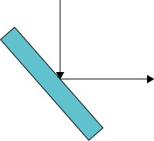

22. What is the relationship between the angle of incidence and the angle of reflection?

23. What do you see when you look in a plane mirror?

24. Match the word with its definition below.

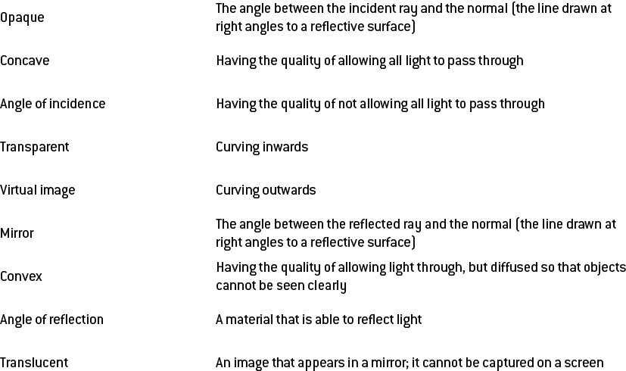

25. Match the following structure within the ear to its correct function.

